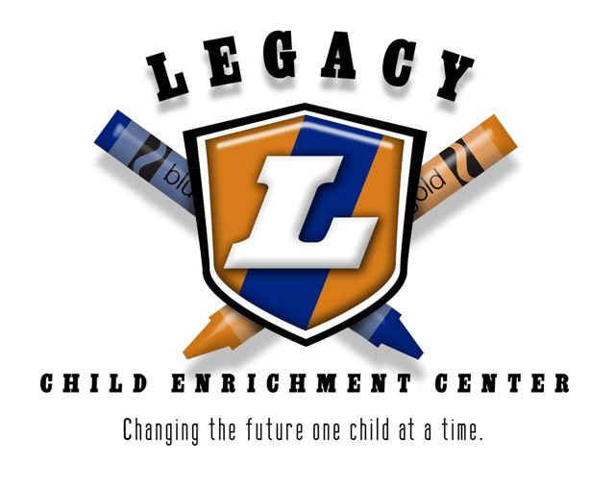
The Legacy Center Closing Dates
for 2018
January 1st (New Year’s Day Observed)
January 15th (Martin Luther King Day)
February 19th (Teacher Work Day)
March 30th (Good Friday)
May 28th (Memorial Day)
July 4th (Independence Day)
September 3rd (Labor Day)
November 22nd & 23rd (Thanksgiving Holiday)
December 24th – 31st (Christmas Holiday)
The day before the Thanksgiving holiday the center will operate on an adjusted schedule of 6:30am to 4pm.

